Start Up LSM 800

1. Turn on main switch
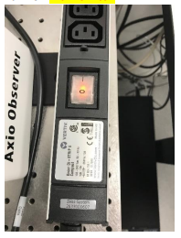
2. Turn on 2 switches in the rack (System + components)
3. Turn the key (laser I)
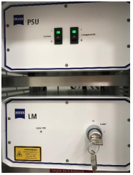
4. Start the PC and Zen software

Shut Down LSM 800

1. Clean objectives and cover the microscope
2. Turn off Zen and the PC
3. Turn the key (laser 0)
4. Turn off 2 switches in the rack (System + components)
5. Switch off the main switch
6. Note time of use and system status in the logbook

